Civil war in Georgia

UNSC Resolution: | 1150
Date of adoption: | 30-Jan-1998
Operative paragraph: | 5
Demand number: | 1150.0511

David Siroky

Wording of demand

work constructively with the SG, his Special Representative for the conflict, the OSCE, Russian facilitators and the Group of Friends of the Secretary-General to achieve a comprehensive settlement

List of addressees of the demand

Government of Georgia, Abkhazia

Short-term compliance

Description of the addressee(s)’ conduct

s/1998/375

Assessment

Short-term compliance
No or marginal compliance (1) | Medium low compliance (2) | Medium high compliance (3) | Full or almost full compliance (4)

Considerations underlying the assessment

Medium-term compliance

Description of the addressee(s)’ conduct

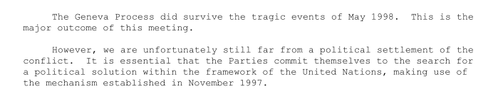

s/1998/647/Add.1

Assessment

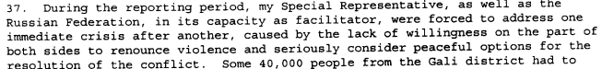
2/1998/647

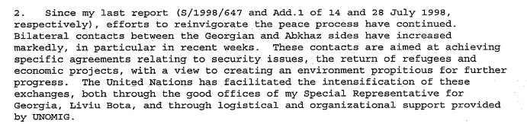

s/1998/1012

Medium-term compliance
No or marginal compliance (1) | Medium low compliance (2) | Medium high compliance (3) | Full or almost full compliance (4)

Considerations underlying the assessment

Depth of demand

Assessment

Level of depth of demand
Low depth of demand (1) | Medium depth of demand (2) | High depth of demand (3)

Considerations underlying the assessment

Level of confidence about coding decisions
Level of confidence about coding decision
Extremely high | High | Moderate

Comments to IPI (if any)

Civil war in Georgia

UNSC Resolution: | 1150
Date of adoption: | 30-Jan-1998
Operative paragraph: | 6
Demand number: | 1150.0611

David Siroky

Wording of demand

intensify the search for a peaceful solution by further expanding contacts

List of addressees of the demand

Government of Georgia, Abkhazia

Short-term compliance

Description of the addressee(s)’ conduct

s/1998/375

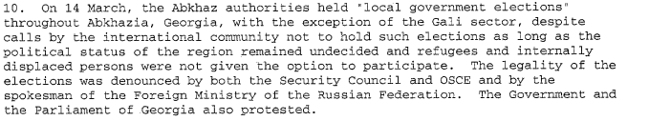

s/1998/375

Assessment

Short-term compliance
No or marginal compliance (1) | Medium low compliance (2) | Medium high compliance (3) | Full or almost full compliance (4)

Considerations underlying the assessment

Medium-term compliance

Description of the addressee(s)’ conduct

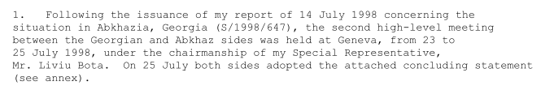

s.1998/647/Add.1

s/1998/1012

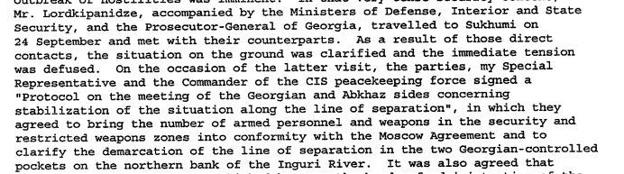

s/1998/1012

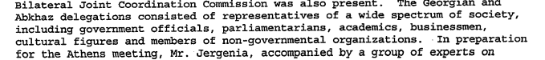

s/1998/1012

Assessment

Medium-term compliance
No or marginal compliance (1) | Medium low compliance (2) | Medium high compliance (3) | Full or almost full compliance (4)

Considerations underlying the assessment

Depth of demand

Assessment

Level of depth of demand
Low depth of demand (1) | Medium depth of demand (2) | High depth of demand (3)

Considerations underlying the assessment

Level of confidence about coding decisions

Level of confidence about coding decision
Extremely high | High | Moderate

Comments to IPI (if any)

Civil war in Georgia

UNSC Resolution: | 1150
Date of adoption: | 30-Jan-1998
Operative paragraph: | 8
Demand number: | 1150.0811

David Siroky

Wording of demand

ensure the full implementation of the Moscow Agreement [S/1994/583 Annex 1]

List of addressees of the demand

Abkhazia

Short-term compliance

Description of the addressee(s)’ conduct

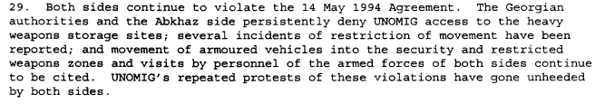

s/1998/647

Assessment

Short-term compliance
No or marginal compliance (1) | Medium low compliance (2) | Medium high compliance (3) | Full or almost full compliance (4)

Considerations underlying the assessment

Medium-term compliance

Description of the addressee(s)’ conduct

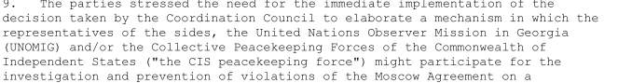

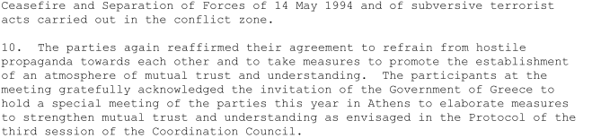
s/1998/647/Add.1

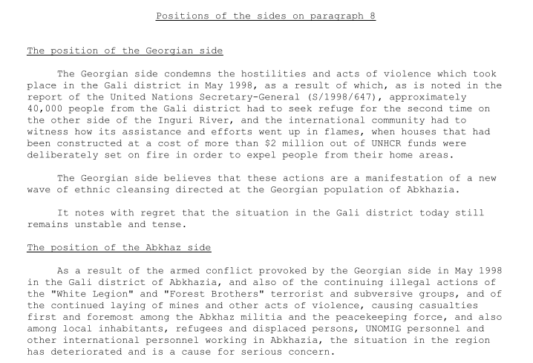

s/1998/647/Add.1

s/1998/1012

s/1998/1012

Assessment

Medium-term compliance
No or marginal compliance (1) | Medium low compliance (2) | Medium high compliance (3) | Full or almost full compliance (4)

Considerations underlying the assessment

Depth of demand

Assessment

Level of depth of demand
Low depth of demand (1) | Medium depth of demand (2) | High depth of demand (3)

Considerations underlying the assessment

Level of confidence about coding decisions

Level of confidence about coding decision
Extremely high | High | Moderate

Comments to IPI (if any)

Civil war in Georgia

UNSC Resolution: | 1150
Date of adoption: | 30-Jan-1998
Operative paragraph: | 9
Demand number: | 1150.0911

David Siroky

Wording of demand

honor fully their commitments to take all measures in their power to coordinate their efforts to prevent intensified actions by armed groups, including the continued laying of mines, in the Gali Region, and to cooperate fully with UNOMIG and the CIS peacekeeping force in order to ensure safety and freedom of movement of all personnel of the UN, the CIS peacekeeping force and international humanitarian organizations

List of addressees of the demand

Government of Georgia, Abkhazia

Short-term compliance

Description of the addressee(s)’ conduct

s/1998/375

s/1998/375

s/1998/375

s/1998/375

Assessment

Short-term compliance
No or marginal compliance (1) | Medium low compliance (2) | Medium high compliance (3) | Full or almost full compliance (4)

Considerations underlying the assessment

Medium-term compliance

Description of the addressee(s)’ conduct

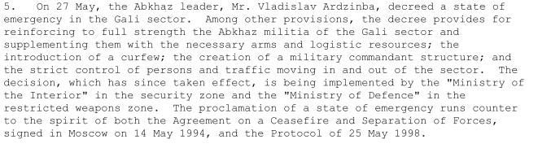

s/1998/497

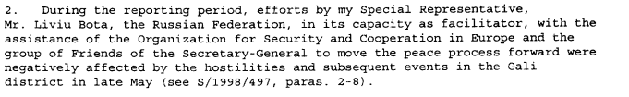
s/1998/647

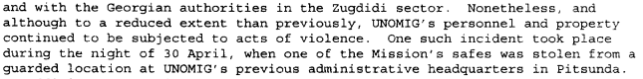
s/1998/647

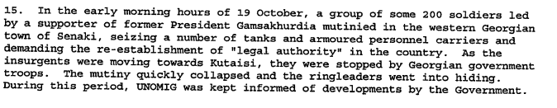

s/1998/1012

Assessment

Medium-term compliance
No or marginal compliance (1) | Medium low compliance (2) | Medium high compliance (3) | Full or almost full compliance (4)

Considerations underlying the assessment

Depth of demand

Assessment

Level of depth of demand
Low depth of demand (1) | Medium depth of demand (2) | High depth of demand (3)

Considerations underlying the assessment

Level of confidence about coding decisions

Level of confidence about coding decision
Extremely high | High | Moderate

Comments to IPI (if any)

to IPI (if any)

